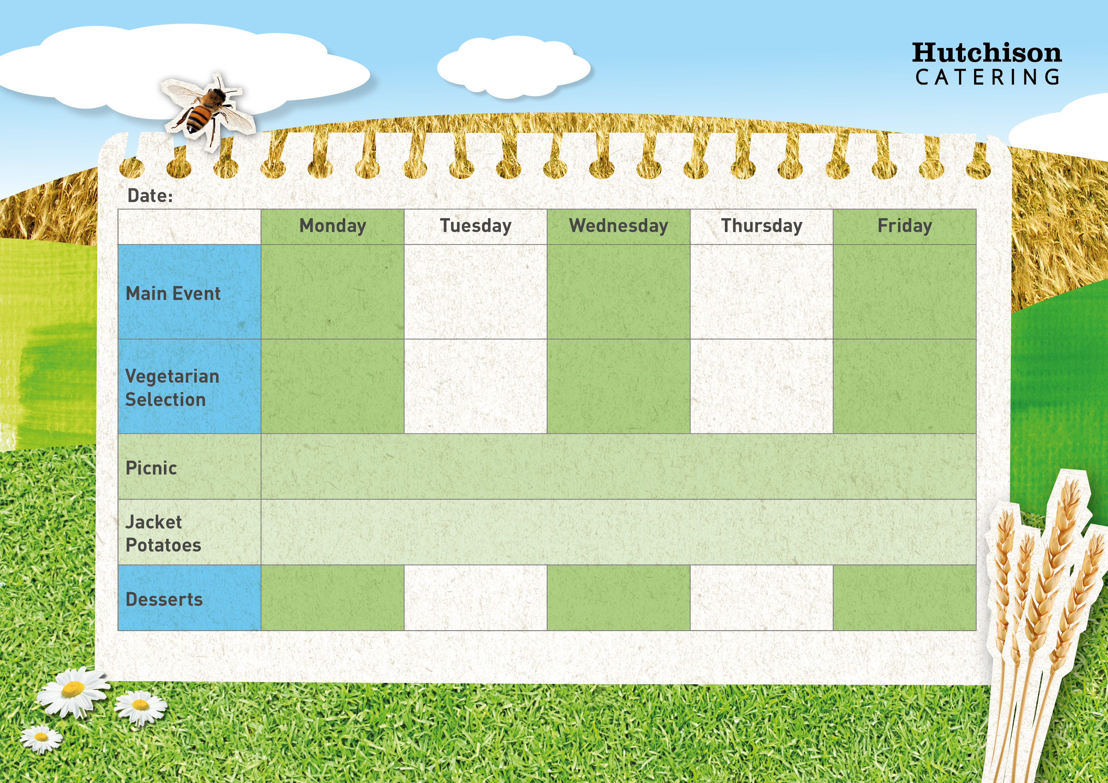

**Freshly Prepared Sandwich with Mixed Salad, Healthy Snack,**

**Dessert of the Day or Fresh Fruit**

**Spring Week 3**

Tomato & Basil Pasta

& with Garlic Bread

Vegetable Pasta Bake

Italian Chicken Pasta with Garlic Bread

Chicken Goujons

With Mexican Rice and Brocolli

Macaroni Cheese with Garlic Bread

**Available Daily:** Fresh Bread, Water, Fresh Fruit and Yoghurt

Ice cream

Sponge Muffin

Chocolate Cookies

Carrot Cake

Flapjacks

**Crispy Baked Jacket Potato with a Choice of Fillings, Mixed Salad**

**Dessert of the Day or Fresh Fruit**

Cheese Pin Wheels with Chips & Baked Beans

Veggie Burger with Potato Wedges and Beans

Fish Fingers with Chips & Baked Beans

Beef Burgers on a bun with Potato wedges and Beans

“Meat Free Mondays”

Margarita Pizza with Potato Wedges & Peas