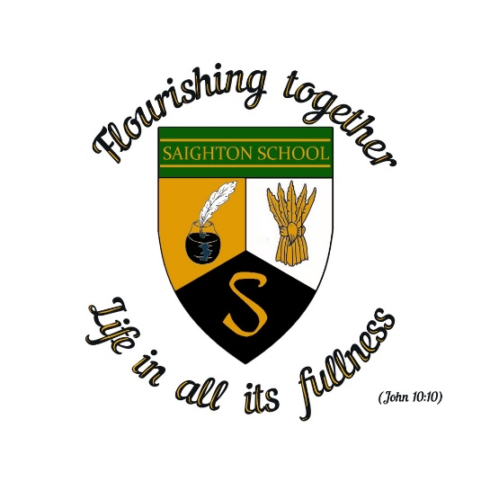

**Saighton Church of England Primary School and Pre-School**

**Pupil Premium Strategy 2022-2023**

**Summary:**

The Pupil Premium Grant (PPG) is a Department for Education funding scheme to help improve the life chances of pupils from a disadvantaged background. ‘Disadvantaged pupils refers to those pupils who attract government pupil premium funding: pupils claiming free school meals at any point in the last six years and pupils in care or who left care through adoption or another formal route. www.gov.uk / pupil-premium-information-for-schools-and-alternative-provision- settings.’

The following is a summary of the funding received by Saighton CE Primary School and Pre-School and how it has been used to benefit the children of the school.

**Funding received 2022/23:**

***For the period April 2022-March 2023, the school has been allocated a total of £5180. This is based on 3 out of our 109 children being eligible for funding in the school (2.7%). These children may have barriers to learning creating by social, emotional or developmental delay or may have learning delays that require additional tutoring to fill gaps and accelerate progress.***

Progress and attainment for eligible and other pupils is reviewed every term through teacher assessments and our wholeschool tracking system. Any progress that is less than expected is scrutinised and teaching methods and inetrventions are adapted accordingly.

**How we are using the funding:**

This year, we have allocated the funding to supporting disadvantaged children, or those at risk of underachieving by:

* providing daily TA support to groups of children and individuals in English and Maths lessons
* providing targeted support during afternoon lessons
* Targeted Speech and Language Assessments for pupils following Wellcomm training for staff.
* running ‘intervention bus’ groups for a daily catch up response to Maths lessons
* funding additional TA hours to work with targeted intervention groups such as phonics and reading sessions
* providing financial support with residential visits, trips, swimming, uniform, kit and music lessons when required at 50% of costs

**What has been the impact of the Pupil Premium funding? (2022/2023)**

* During the 2022/2023 period the focus has been on closing the gap in pupils writing and phonics knowledge.
* 15 out of 17 Year 1 pupils passed the phonic screening check in June 2022 compared with only 4 of them achieving a pass score during checks in March 2022.
* Positive scrutiny of progress and attainment for all pupil groups including Pupil Premium pupils- Ofsted Inspection October 2022.

**What Next for 2023/2024?**

* Funding for 2023/2024 is £9805 based on 6 pupils being eligible.
* Focus in 2023/2024 will be on intervention and small groups support in areas identified by staff as weaknesses, including phonics, mental maths and small group writing support.
* The pupil premium strategy will be reviewed each term- Nov 2023, March 2024 and July 2024.
* For more information about Pupil Premium please see the Department for Education website via:

<http://www.education.gov.uk/schools/pupilsupport/premium>