**Saighton Church of England Primary School & Pre-School**

**Saighton Lane, Saighton, Chester, CH3 6EG**

**‘Flourishing Together. Life in all its fullness’**



**Attendance and Lateness Policy**

Every minute counts!

5 minutes late each day = 3 days lost learning

15 minutes late each day = 10 days lost learning

30 minutes late each day = 19 days lost learning

17 days lost = 1 level less than a child’s capability is achieved

ATTENDANCE AFFECTS LEARNING AND FUTURE OUTCOMES!

**PUNCTUALITY**

The school gate opens at 8.45 am for all children.

Children are expected to arrive from **8.45 am – 8.55 am**.

During this time the teacher will register the children whilst the children complete a range of activities.

The first teaching session begins at **9.00am**. Therefore, we ask that all children are in school and ready to learn by **9.00am** at the latest.

**Doors close at 9.00 am**.

Pupils arriving to school after this time will be entered as Late – ‘L’ (before the registers close) .

Pupils arriving after 9.20 am will be marked as Late – ‘U’ (after the registers close).

# *Late after the close of registration is an unauthorised absence*

Pupils who are consistently late are disrupting not only their own education, but also that of others.

Saighton Church of England Primary School & Pre-School aims to have all pupils attending regularly and punctually and parents/carers need to know that should their child fail to attend in this way then the matter will be referred to the Education Welfare Officer (EWO).

The Headteacher receives information from the School Business Manager on pupils who are persistently late or absent, in her capacity as Attendance Officer. In the first instance a letter will be sent to parents informing them of their child’s absence.

# ABSENCE FROM SCHOOL

It is the parent’s responsibility to inform school of any absences and the reason for it. In some cases, a whole week’s absence is not necessary and could lead to a Fixed Penalty Notice. You could be at risk of a Fixed Penalty Notice if your child has had 10 consecutive sessions of unauthorised absences (5 days) or more and if you have not provided a valid reason or proof.

You can inform the school office of your child’s absence by 9.10 am using any of the following methods:

1. By phoning 01244 335822 and selecting Option 1 to leave a message on the absence line. Please leave your child’s name, class and the nature of his/her symptoms. Please note that merely saying ‘unwell’ or ‘under the weather ’is not sufficient information and the absence cannot be authorised.

2. By using the ‘Absence Tab’ in ParentMail, again providing your child’s name, class and symptoms.

3. By email to [admin@saighton.cheshire.sch.uk](mailto:admin@saighton.cheshire.sch.uk). Please do not email the class teacher.

If the school office has not received an absence notification by 9.20 am, an attempt

will be made to contact parents by phone in the first instance, then email.

**Authorised Absences**

The following absences will be authorised:

* Pupil illness (but not illness of parents)
* Medical appointment
* Close family bereavement or funeral
* Leave of absence granted by the Headteacher in exceptional circumstances. A **Leave of Absence Request Form,** which can be found under the ‘Parent Tab’ on the school website, should be completed and submitted to the school office at least one week before the proposed absence with details of why the absence is being applied for under exceptional circumstances. The Headteacher will then send a letter explaining if the absence is authorised or unauthorised. Unauthorised absences of 20 sessions (or 5 school days) may result in the issuing of a Fixed Penalty Notice by the local authority.

**Unauthorised Absences**

The following absence will not be authorised:

* If another family member is unwell
* A day off for a birthday or other day out
* Leave of absence not authorised by the Headteacher
* Shopping trips for shoes, clothes etc

# FIXED PENALTY NOTICES FOR ATTENDANCE

If your child fails to attend school on a regular basis, then you are at risk of a Fixed Penalty Notice being issued to both parents, even if you do not live together. The Local Authority will be informed if your child has low or decreasing attendance below 85% if there is a pattern of irregular attendance e.g. around weekends or school holidays.

Regular attendance reviews will be conducted throughout the school year and parents will be contacted by the Headteacher once a child’s attendance falls to 95% or below to discuss how school can support improved attendance.

The school will decide if a Fixed Penalty Notice should be issued. If there has been no sustained improvement in your child’s attendance or there have been any more unauthorised absences, then the local authority will proceed with the penalty. You will receive the notice, together with a covering letter sent from the Education Welfare Service. This notice gives you the opportunity to pay a penalty fine instead of being prosecuted in the criminal courts.

# INCENTIVES FOR ATTENDANCE

We encourage all the children at Saighton Church of England Primary School & Pre-School to have good attendance. Our attendance targets for the year are 97%.

Each week, the Headtecher will be informed by the School Business Manager of any class with 100% attendance and house points will be awarded. Each term, children with 100% attendance receive a 100% certificate which is awarded in a special celebration assembly. In the summer term, children who have attained 100% receive a special certificate for the whole year.

# CHESHIRE WEST AND CHESTER ATTENDANCE AND LATENESS GUIDANCE

Saighton Church of England Primary School & Pre-School has adopted the following

Guidance.

# Introduction

A good and sustained level of attendance is essential for pupils learning and attainment and opening more opportunities for their future. Facts that you will know, but are pertinent to share with pupils, parents and carers are:

* a child who is absent a day of school per week misses an equivalent of two years of their school life
* 90% of young people with absence rates below 85% fail to achieve five or more good grades of GCSE and around one third achieve no GCSEs at all
* poor examination results limit young people’s options and poor attendance suggests to colleges and employers that these students are unreliable
* poor school attendance is also closely associated with crime, a quarter of school age offenders have truanted repeatedly
* at least 1 million children take at least one half day off a year without permission
* 7.5 million school days are missed each year through unauthorised absence.

Absence at any stage leads to gaps in a pupils’ learning. This in turn can:

* mean that they fall behind in work
* affect their motivation
* affect their enjoyment of learning
* lead to poor behaviour
* affect their desire to attend school regularly
* affect their confidence in school
* mean they miss out on the social life of school and extra-curricular opportunities and experiences
* affect their ability to have or keep good friendships

**Education Act 1996** *section 444*

**Children Act 1989** *ESO* (*paragraph 18(1), Schedule 3*, *Children Act 1989*

# Anti-social Behaviour Act 2003

**School Attendance Prosecutions**

If a parent fails to get their child to regularly attend school, the School and Local Authority (LA) should make reasonable efforts to resolve the problem before resorting to legal action. If, however, it becomes apparent that all other avenues have been explored, the information below gives information regarding the legal landscape the offences fall within.

# The offences

Local Authorities have the power to prosecute parents who:

* Fail to ensure their child’s regular attendance at school (*section 444*, *Education Act (EA) 1996*).
* Knowingly allow their child to be absent from school without authorisation (*section 444(1A)*, *EA 1996*).
* Persistently fail to comply with directions given under an Education Supervision Order (ESO)

(*paragraph 18(1), Schedule 3*, *Children Act 1989*

Only the LA can prosecute parents for the offences found in section 444 of the Education Act 1996 (*section 446*, *EA 1996*) and they must fund all associated costs.

# Failure to ensure child’s regular attendance at school (sec 444(1))

Parents are guilty of an offence for failing to ensure that their child regularly attends school (*section 444(1)* and *(ZA)*, *EA 1996*).

With regards to the section 444(1) offence, a LA will need to prove to the criminal standard that the child is a registered pupil at a relevant school and that he is of compulsory school age and has failed to regularly attend school without authorisation. The only evidence that the LA will need to provide the court with, is the certificate of attendance and why an Education Supervision Order is not appropriate.

# Knowingly allowing a child to be absent from school without authorisation sec 444(1A))

It is regarded as a more serious offence when a parent **knowingly** allows a child to be absent from school without authorisation (*section 444(1A)*, *EA 1996*). In such circumstances, a LA will need to show that the child failed to regularly attend school without authorisation, and that the parents **knew and failed, without reasonable justification**, to ensure that their child regularly attended school.

The EA 1996 does not define “reasonable justification” but case law tells us that it is to be approached as a perfectly understandable English expression and that it was unnecessary for every single avenue to be explored to ensure that a child received “schooling”, as that was immaterial to attendance at school. ‘Reasonable justification” seems to be a question of fact relating to the child’s attendance at school and is, therefore, to be looked at in that context.

# Regular attendance

The essential element in both the offences under sections 444(1) and 444(1A) of Education Act 1996 is whether the child has regularly attended school. While the term “regular attendance” has been in use since the Education Act 1944, there is no statutory definition of it.

The Supreme Court in the ‘Isle of Wight Case’ interpreted the word “regularly” in section 444(1) of the Education Act 1996, after having considered Parliament’s intention and the history of the requirement for parents to ensure their child’s attendance at school. The justices determined that “regularly” means at all times required by the rules prescribed by the school. “Full-time” education means all of the time when education is being offered to the child

Each school should have its own policy about what level of attendance it considers to be ‘regular attendance’ and when a Fixed Penalty Notice will be issued and when it will consider a prosecution. The acceptable attendance level may be different for each school. The following should be considered when deciding whether to prosecute a parent:

* The prosecution policy should be sensible. It is possible to successfully prosecute a day’s absence, but a criminal conviction may not be a proportionate response.
* The parent’s explanations for any absence may reveal problems that could be dealt with differently to resolve the non-attendance issue.
* The parent’s recognition that full-time education and school attendance is important to their child’s development.
* The clarity of the school’s policy on absence.
* The ways that the school’s policy on absence has been sufficiently made known to parents.
* You must consider whether an Education Supervision Order is appropriate, and detail your consideration of this in your witness statement if you decide it is not.
* If prosecution does not appear appropriate as other issues have come to light, would a Parenting Contract be of use?
* Do the issues presented by the family trigger a referral to other support agencies/organisations?

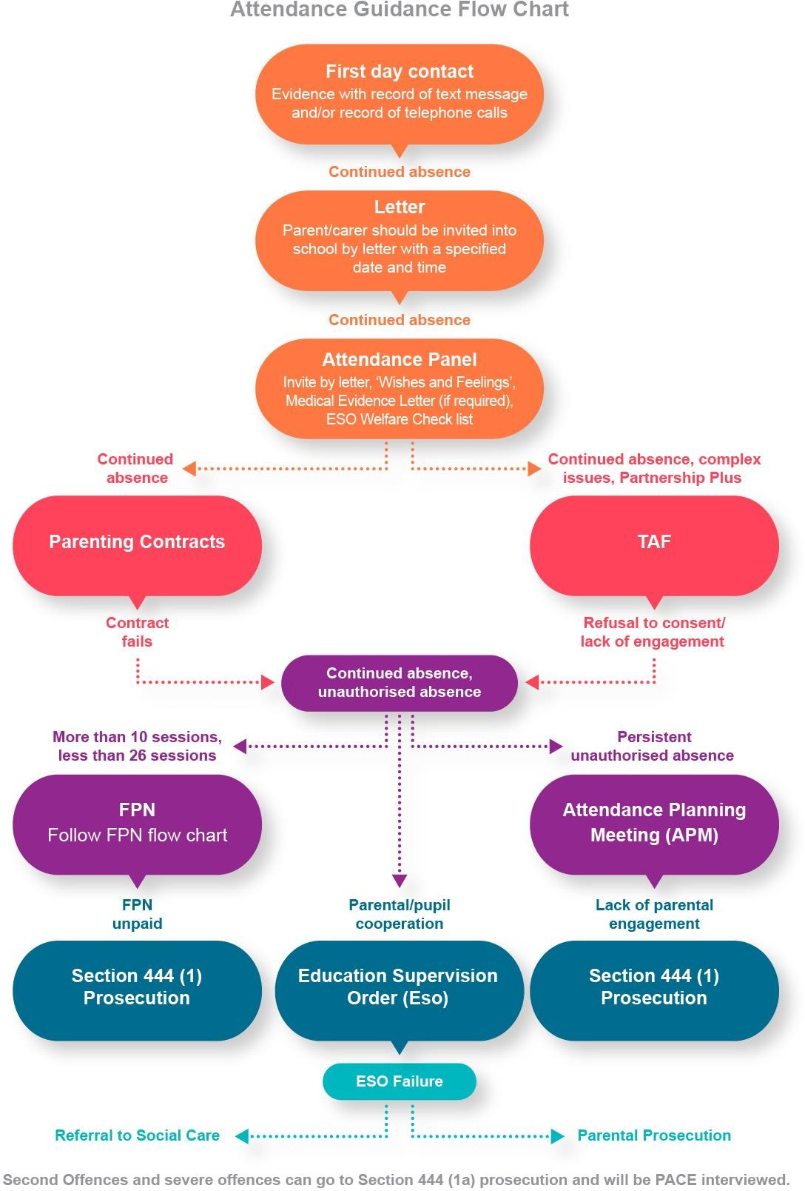

# School Expectations of Good Attendance

To maintain the profile of ‘good school attendance’ Saighton Primary School & Pre-School

has:

* a clear and coherent school attendance policy
* the Headteacher named as the Attendance Lead
* a definition of parental responsibility for attendance, an outline of the law, the start and finish of the school day and the attendance procedure in the school prospectus, website, newsletter etc

**First Day Contact** – the school has a system of first day contact to ensure that the parents who have not notified school of their child’s absence are contacted to ascertain the reason for absence. This is usually a telephone call to both parents, followed by an email if contact cannot be made.. All attempts to contact parents in cases of poor attendance should be recorded and kept as evidence for any possible future legal action.

**Attendance Letter -** A letter should be sent home notifying the parent of their child’s

absences.

**Meeting -** If absences continue and a parent still fails to contact school, provide a reason for absence, or the reasons for absences are questionable, a letter should be sent to invite the parent into school for a meeting at a specified date and time to meet with a named member of staff. The letter must include the parent’s full name, the child’s name and date of birth. Please ensure that the parent names and contact details are up to date and in line with the General Data Protection Regulation 2018 (GDPR 2018)

# *It is at this point that all contact with the parent should be regarded as possible evidence for any future legal proceedings.*

**Attendance Panels**

The school holds regular Attendance Panels in school to provide opportunities for constructive communication between the school and parents. The use of Attendance Panels also concentrates resources as several families can been seen in one period of time.

A letter, including the parent’s full name, the child’s name and date of birth, should be sent to parents inviting them to attend the panel. The child may also be invited depending upon age and aptitude. Panels may vary from settings to settings and can be made up of any relevant members of staff who are working with the pupil, but the panel should be chaired by the head teacher or a member of the senior leadership team. A governor may also be invited.

Prior to the panel, ‘wishes and feelings’ should be completed with the pupil. There are many tools for use available to do this in ‘Voice of the Child ‘guidance. [voice of the child](http://ies-news.info/2015/02/02/voice-of-the-child/)

Attendance Panels provide the opportunity to consider:

* + Medical evidence letters
  + Parenting contract (chapter 5)
  + TAF if there are multiple issues (see chapter 5)

Schools are now asked to consider an Education Supervision Order, (chapter 6) As the Litigation and Corporate team state in Chapter 4, you must consider whether an Education Supervision Order is appropriate or not. You can do this at an Attendance Panel by using the Welfare Checklist list.

# WELFARE CHECK LIST

. There are a number of principles, which the Children Act 1989 requires the Court to consider before making an Order.

# Ascertainable wishes of the child

* + Physical, Emotional and Educational Needs
  + The likely effect on > of any changes in her circumstances
  + Any harm which > has suffered or is at risk of suffering
  + How capable are her parents of meeting her/his needs
  + Age, sex, background and any characteristics of her/him which the Court consider relevan

# Parenting Contracts

Parenting contracts can be used in cases of irregular school attendance. A parenting contract is a formal, written, signed agreement between parents and the governing body of a school.

A parenting contract should:

* Contain a statement by the parents that they agree to comply for a specified period with whatever requirements are set out by the school in the contract.
* Contain a statement by the governing body, agreeing to provide support to the parents for the purpose of complying with the contract.
* Be signed by the parent(s) and signed on behalf of the governing body.

Parenting contracts are voluntary, but any non-compliance should be recorded by the school or LA so that it can be used as evidence in court if an application is made for a parenting order. The LA or governing body should fund any support required to implement a parenting contract (for example, a referral to parenting classes) and provide information to parents about other types of support available, such as details of national and local agencies and helplines.

(**Appendix 4** Sample parenting contract)

# TAF - Team around the family

The Team Around the Family (TAF) is Cheshire West & Chester’s approach to conducting an assessment of a family's additional needs (including the needs of the child/ren) and deciding how those needs should be met. It is used by practitioners across children's services in West Cheshire. The TAF promotes more effective, earlier identification of additional needs. It provides a simple process for assessment of a family's needs and strengths, taking account of the role of parents, carers and environmental factors on children's development. Practitioners will then be better placed to agree, with the child and family, about what support is appropriate. The TAF also helps to improve integrated working by co-ordinating services and ensuring better information sharing.

You can evidence the offer of a TAF with the TAF consent form and Privacy Notice.

Links to TAF guidance and Multi-agency toolkit

[https://www.cheshirewestandchester.gov.uk/residents/health-and-social-care/children-](https://www.cheshirewestandchester.gov.uk/residents/health-and-social-care/children-and-young-people/team-around-the-family.aspx) [and-young-people/team-around-the-family.aspx](https://www.cheshirewestandchester.gov.uk/residents/health-and-social-care/children-and-young-people/team-around-the-family.aspx)

<https://www.cheshirewestlscb.org.uk/multi-agency-assessment-toolkits/>

**Education Supervision Orders ESO)**

* The Children's Act 1989 allows the Local Education Authority to apply for an Education Supervision Order on any child of compulsory school age, whom it is felt, is not being properly educated.
* An Education Supervision Order lasts for one year initially, but may be extended for up to three years on application.
* The school will appoint a Supervisor
* The Supervisor has a duty to advise, assist and support the child on whom the order has been made, and to offer support to his/her parents.
* The Supervisor will work in partnership with the child and his/her family to ensure that he/she receives an appropriate education.
* The wishes and feelings of the child must be taken into account whenever practicable.

If an Education Supervision Order is made on a child, he/she will be required to:

* Attend school regularly.
* Allow the Supervisor to visit him/her at the place where he/she is living.
* Meet with the Supervisor on a regular basis.
* Discuss with the Supervisor any problems which arise which could prevent him/her attending school.
* Keep to any reasonable instruction which the Supervisor may give.

Throughout the period of the Order, parents retain parental responsibility for their child, and must continue to ensure that their child attend school regularly. They must also meet with the Supervisor on a regular basis, and allow the Supervisor reasonable contact with the child. They must co-operate with any strategies proposed by the Supervisor.

An Education Supervision Order is imposed when it is proved to the Court that a child is not being educated according to his age, ability and aptitude, taking into account any educational needs he/she may have. During the period of the Order, half termly review meetings will be held at which the child, parent, supervisor, and the District Education Welfare Officer discusses whether the Order is working and what future plans need to be made.

If the Order is successful, and no extension is applied for, it will lapse after the 12-month period.

If a parent does not co-operate with the Supervisor in working within the requirements of the Order, the parent could be referred back to the Court. A fine of up to £2,500 could be imposed on the parent.

If a child does not co-operate with the Supervisor, he/she can be referred back to the Court who could direct the Social Care and Health Department to become involved and consider applying for a higher order.

(**Appendix 3** A Guide to Education Supervision Orders for Parents; A Guide to Education Supervision Orders for Pupils; Directions for Education Supervision Order; ESO Statement; ESO Welfare Checklist)

# Fixed Penalty Notice (FPN)

Fixed Penalty Notices are used as an early intervention to tackle low level irregular attendance. They are not to be viewed as a punitive measure or to tackle entrenched long term attendance problems. In cases of persistent absence and where there is historic absence a prosecution should be considered.

The EWS will consider issuing a FPN warning letter if the unauthorised absence is greater than 10 sessions and less than 26 sessions in a term and there is evidence of the following:

* First Day contact
* Letter to parent advising of irregular attendance
* Letter of invite to attend meeting in school
* Letter of invite to Attendance Panel
* Minutes of Attendance Panel, if parent attended
* ESO consideration (FPN)

FPN warning letters should be requested in a timely manner as historic absences will not meet legal deadlines.

When a FPN warning letter is issued by the EWS, the school will be sent a copy of the letter and notification of the 15-day monitoring period, including the first day of the monitoring period and the last day of the monitoring period.

At the end of the monitoring period, it is the **responsibility of the school** to send a registration certificate to the EWS. The registration certificate must be received within 10 days of the end of the period to ensure that legal timescales are met.

* + **No unauthorised absence** in the monitoring period, no further action and the action is closed.
  + **Unauthorised absences** in the monitoring period, the EWS will request that a penalty notice is issued. On receiving the penalty notice, parents have up to 21 days to pay

£60 per child per parent, after 21 days and up to 28 days the penalty notice increases to £120.

* + **Penalty notice is paid**; there is no further action for EWS and school continues to monitor attendance.
  + **Penalty notice is unpaid**; the EWS will complete a FPN section 9 witness statement. The school must complete a head teacher’s certificate stating the dates of the absences and the monitoring period.

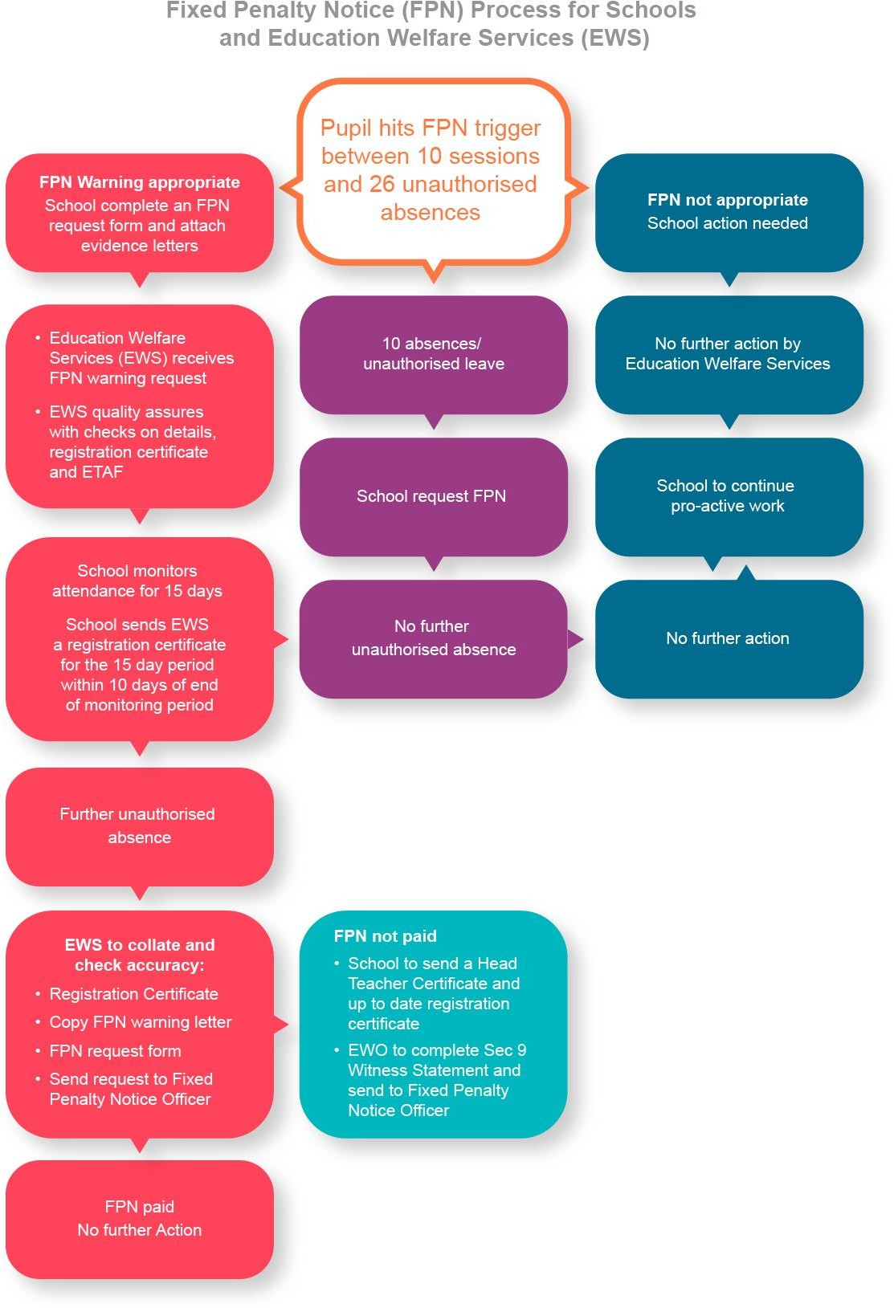

# Warning Letters/Attendance Planning Meetings

**First Warning Letter**

For more severe and entrenched poor attendance, cases should now be considered for a Section 444 (EA 1996) prosecution.

If there is continuing irregular attendance and **unauthorised absence** and there is evidence that a parent is failing to ensure their child’s regular attendance at school a First Warning Letter is issued.

The letter specifies the sessions that the child has attended and the sessions he/she has been absent. The letter also states ***section 444, Education Act 1996)*** and **(*section 444(1A)*, *Education Act 1996*)** to inform parent of their responsibility and is evidence in any possible future legal action that the parent had been informed of the absence.

(**Appendix 7** First Warning Letter)

# Attendance Planning Meeting (APM)

This meeting usually occurs between the **First Warning Letter** and the **Final Warning Letter** and is a good tool to use to further investigate continued poor attendance and unauthorised absence and warn parents of possible legal proceedings.

This is a formal meeting and is can be used as part of the legal process. Parents should be invited to attend an **APM** by letter. The meeting should be attended by the parent and child, relevant members of staff involved with the child, other agencies working with the child and should be chaired by a member of the senior leadership team.

It is a last chance to find solutions to improve attendance and is an opportunity to consider whether parents meet any of the 4 statutory defences. (Education Act 1996 sec 444(3)(4))

‘The child shall not be taken to have failed to attend regularly at the school by reason of his absence from the school:

* with leave,
* at any time when he was prevented from attending by reason of sickness or any unavoidable cause
* on any day exclusively set apart for religious observance by the religious body to which his parent belongs.
* The child shall not be taken to have failed to attend regularly at the school if the parent proves:

that the school at which the child is a registered pupil is not within walking distance of the child’s home, and

that no suitable arrangements have been made by the local education authority [**F2**](http://www.legislation.gov.uk/ukpga/1996/56/section/444#commentary-c15250431). . . for any of the following—

1. transport to and from the school,
2. boarding accommodation for him at or near the school, or
3. enabling him to become a registered pupil at a school nearer to his home.
4. In subsection (4) “walking distance”—
   1. in relation to a child who is under the age of eight, means 3.2 kilometres (two miles), and
   2. in relation to a child who has attained the age of eight, means 4.8 kilometres (three miles), in each case measured by the nearest available route’

(**Appendix 8** sample APM forms)

# Final Warning Letter

If the child continues to be absent from school, after the First Warning Letter has been sent and an APM has been offered, the Final Warning Letter should now be sent.

This informs the parent that the school is referring the matter to the LA to instigate Legal Proceedings. You can now start collating your evidence to write the Section 9 Witness Statement.

(**Appendix 9** Final Warning Letter)

# Section 444 prosecutions Section 9 Witness Statement

A witness statement is a formal introduction of evidence in **criminal** proceedings. It provides a narrative of your involvement in a case/investigation and forms key element of the local authority’s prosecution case against the Defendant. It should provide facts and details of causal connection between commission of the offence and the Defendant’s role in its commission to concisely, clearly and accurately assist the Court.

Essentially it is your chronology of your involvement in the case. Below are paragraphs we would suggest you include to logically give your account of how the case has been handled:

# Your Personal Details:

Name of person writing statement – job title – place of work – length of time in employment

# Details of Pupil and Parent/Defendant:

Name of pupil – date of birth – year group – parent (who is defendant) – home address.

# Attendance Issues:

Initial attendance concerns – figures

# Case Work:

Steps taken when attendance was noticed to be in decline – did the issue continue? How was it managed, how did you engage with family? What was their response, if any?

# Consideration of ESO

Why did you rule out an ESO being appropriate?

# Consideration of prosecution

How did you reach your decision to prosecute?

# FPN Consideration

If you have requested an FPN which has been unpaid, please detail why you decided to issue an FPN in this case.

If you have moved straight to prosecution and not offered an FPN then you do not need to include this paragraph.

--------------------------------------------------------------------------------------------------------------

This information can now be put on the sec 9 Witness Statement. The statement and the evidence below should now be sent to the EWS.

* + - Head Teachers Certificate
    - Registration Certificate
    - Copy of warning letters sent to parents
    - Copy Medical Certificate (if relevant)
    - Copy Letters from parents, if relevant
    - ESO consideration (Sec 444)

(**Appendix 10** Section 9 Witness Statement, Prosecution Chronology)

# Notification of Prosecution

Once the EWS has received the legal paper work it will quality assure and check

* that an offence has been committed
* that the prosecution is fair and equitable
* it is in the public interest and good use of public monies

This is to ensure that prosecutions are safe and effective and aim to result in the outcome of improving school attendance.

The EWS will then write to the parent to notify them that legal proceedings are being instigated. School will receive a copy of this notification.

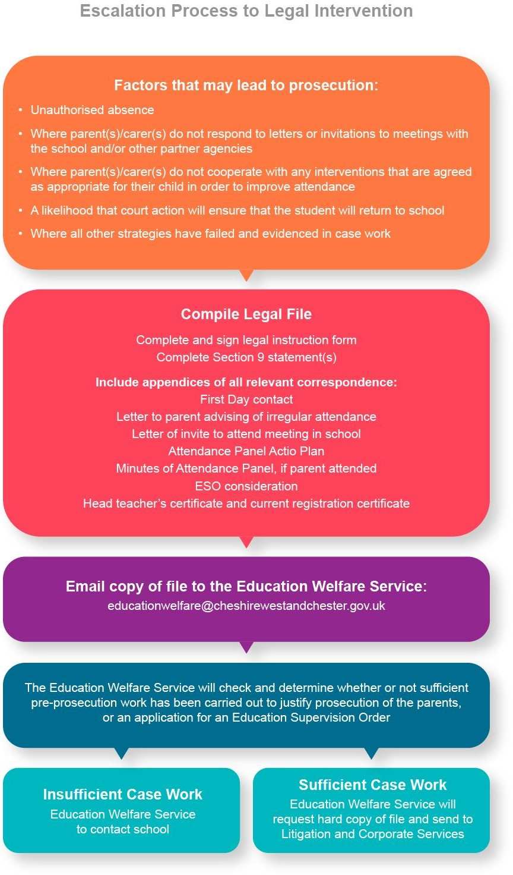

# PACE

**Knowingly allowing a child to be absent from school without authorisation**

**(sec 444(1A))**

It is regarded as a more serious offence when a parent **knowingly** allows a child to be absent from school without authorisation (*section 444(1A)*, *EA 1996*). In such circumstances, a LA will need to show that the child failed to regularly attend school without authorisation, and that the parents **knew and failed, without reasonable justification**, to ensure that their child regularly attended school.

A PACE interview is a means whereby evidence is gathered to show the extent of a parent’s knowledge of the non-attendance of their child and whether they have a reasonable justification. An explanation is given to parents as to why they are being interviewed. They are allowed to gain access to a legal representative, interpreters and appropriate adults (e.g. where the parent has mental health problems) as appropriate.

Before asking any questions relating to the potential prosecution, the interviewer should explain to the parent the basis on which the interview is being conducted i.e. that the LA is considering prosecuting the parent under s 444 (1A) Education Act 1996. They should explain what the offence is and check that the parent understands what has been said. A caution is given to parents as follows:

*You do not have to say anything, but it may harm your defence if you do not mention when questioned something which you later rely on in court. Anything you do say may be given in evidence.*

The interviewer should satisfy himself or herself that the parent understands the effect of the caution. If there is any break in the interview, the parent must be reminded that they are still under caution. This would also apply if for example the caution is included in a letter inviting the parent to the meeting.

An interview should not be carried out if:

* + - the parent is mentally vulnerable and there is no appropriate adult available
    - the parent is under the influence of alcohol or drugs
    - the parent is suffering from illness, ailment or other condition which may impair their ability to understand and answer the questions put to them in interview.

An accurate record must be made of each interview stating the place, time to which it begins and ends the time the record is made. If possible the interview should be tape recorded or through written notes.

The tape should be sealed with the date written on of the interview and parents should receive a written letter stating that the tape will be used as evidence in court.

The Interview process

* The interviewer summarises the case and sets out the facts that will be used as evidence (warning letters).
* The parent and solicitors may serve a defensive statement setting out the nature of defensive and any matters on which they take issue.
* The parent is asked about the letters that were sent out regarding their child’s attendance and any meetings which were arranged in which parent’s did not attend.
* The parent may give a further defence before the case is summarised.
* (**Appendix 11** PACE Chronology)

Appendices:

Appendix 1 Attendance Panel Documents

    

Attendance Panel Meetings - Guidelines

Attendance Panel - Invite Letter to Parent'

Attendance Panel - Meeting Action Plan.d

Attendance Panel - Failed to Attend Letter

Attendance Panel - Panel Attended Letter

Appendix 2 Medical Evidence Letter



Sample Medical Evidence Letter.docx

Appendix 3 Education Supervision Order (ESO) Documents

   

A Guide to Education

A Guide to Education

Blank ESO

ESO WELFARE

Supervision Orders - P Supervision Orders - P StatementWelfare Ch CHECKLIST CONSIDER

Appendix 4 Sample Parenting Contract



PARENT CONTRACT

template.doc

Appendix 5 Irregular FPN warning letter request form (Checklist)



FPN Checklist for Schools - Jan 2018.do

Appendix 6 Head Teacher’s certificate



Blank Head Teachers certificate.doc

Appendix 7 First Warning Letter



FIRST WARNING

LETTER - Sample Letter

Appendix 8 Attendance Planning Meeting (APM) Documents

  

|  |  |
| --- | --- |
| Date of Last Review: | July 2023 |
| Next Review Due: | July 2024 |
| Approved by Governing body: |  |