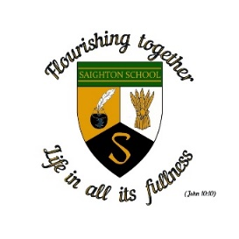

**Saighton Church of England Primary School & Pre-School**

**School term dates 2024-2025**

**Autumn Term 2024**

**Monday 2nd September INSET (Staff training day)**

Tuesday 3rd September Pupils return to school

Friday 25th October School closes for half term

**Half term: Monday 28th October – Friday 1st November**

Monday 4th November School reopens

Friday 20th December School closes for Christmas holidays

**Christmas holiday: Monday 23rd December to Friday 3rd January**

**Spring Term 2025**

**Monday 6th January INSET (Staff training Day)**

Tuesday 7th January School reopens

Friday 14th February School closes for half term

**February half term: Monday 17th February – Friday 21st February**

Monday 24th February School reopens

Thursday 3rd April School closes for Spring Break

**Friday 4th April INSET (Staff training day)**

**Spring Break: Monday 7th April – Tuesday 22nd April**

**(including Bank holiday)**

**Summer Term 2025**

Wednesday 23rd April School reopens

Monday 5th May Bank holiday

Friday 23rd May School closes for half term

**Half term Monday 26th May - Friday 30th May**

**Monday 2nd June INSET (Staff training day)**

Tuesday 3rd June School reopens

Tuesday 22nd July School closes for summer holiday

**Wednesday 23rd July INSET (Staff training day)**