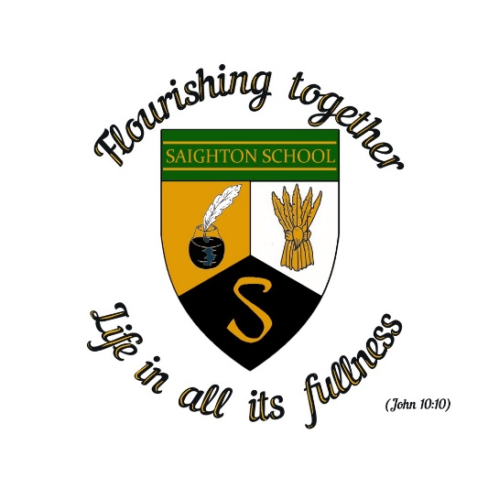

Saighton Church of England Primary School & Pre-School

Sports Grant Allocation 2024-2025

Total Allocation: £16,800

The premium must be used to fund additional and sustainable improvements to the provision of PE and sport, for the benefit of primary-aged pupils, in the 2024 to 2025 academic year, to encourage the development of healthy, active lifestyles.

Department for Education Vision for the Primary PE and Sport Premium ALL pupils leaving primary school physically literate and with the knowledge, skills and motivation necessary to equip them for a healthy, active lifestyle and lifelong participation in physical activity and sport.

It is expected that schools will see an improvement against the following 5 key indicators:

1. The engagement of all pupils in regular physical activity. All children aged 5-18 should engage in at least 1 hour of physical activity a day, of which 30mins should be at school

2. The profile of PE and sport being raised across the school as a tool for whole school improvement

3. Increased confidence, knowledge and skills of all staff in teaching PE and sport

4. A broader experience of a range of sports and activities offered to all pupils

5. Increased participation in competitive sport

More information can be found at:

<https://www.gov.uk/guidance/pe-and-sport-premium-for-primary-schools>

|  |  |
| --- | --- |
| Summary of Funding Use 2024-2025 | Cost |
| Sports Coaches for KS1 & KS2 PE Upskilling & Improving Confidence  Sports Coaches used part of lunchtime supervision | £15000 |
| Swimming pool hire, lifeguard & instructor for KS2 pupils to facilitate reaching National Curriculum standards in swimming &  Coach Travel to and from swimming pool | £5000 |
| Sports Competitions- buy to the cluster of schools sports co-ordinator to facilitate sports events and competitions between local small schools | £300 |
| Playtime equipment allocation | £500 |
| Total Expenditure | £20800 |

|  |  |
| --- | --- |
| Swimming & Water Safety 2024-2025- 13 pupils | % |
| What percentage of your current Year 6 cohort can swim competently, confidently and proficiently over a distance of at least 25 metres? | 85 |
| What percentage of your current Year 6 cohort can use a range of strokes effectively [for example, front crawl, backstroke, and breaststroke? | 85 |
| What percentage of your current Year 6 cohort are able to perform safe self-rescue in different water-based situations? | 85 |
| If your schools swimming data is below national expectation, you can choose to use the Primary PE and sport premium to provide additional top-up sessions for those pupils that did not meet National Curriculum  requirements after the completion of core lessons. Have you done this? | Yes – top up swimming sessions. KS2 swim for 38 weeks of the school year on rotation between each year group totalling at least 40 weeks of swimming lessons by the end of KS2. |

Proposed expenditure for 2025/2026

* Upskilling & Improving Confidence for KS1 & KS2 Staff
* Sports Coach for lunch break to lead games
* Sports Ambassador Training
* Swimming Pool hire, lifeguard and instructor
* Cluster Sports Co-ordinator & Competition Entry
* KS2 Top Up Swimming Sessions (28 weeks)
* Bikeability